Functions, methods and scope

📑 Table of Contents

1. Functions, Methods and Scope
- 1.1 Introduction
- 1.2 What Are Functions?
- 1.3 Key Benefits of Functions
- 1.4 Structure of a Function
- 1.5 Using Functions in a Program

2. Example 1: Rectangle Area Function
- 2.1 Problem Statement
- 2.2 Step-by-Step Code Construction
  - 2.2.1 Step 1: Define the Function
  - 2.2.2 Step 2: Call the Function
- 2.3 Full Code Block: Rectangle Area Function

3. Example 2: Triangle Area Function
- 3.1 Problem Statement
- 3.2 Step-by-Step Code Construction
  - 3.2.1 Step 1: Define the Function
  - 3.2.2 Step 2: Call the Function
- 3.3 Full Code Block: Triangle Area Function

4. Methods in C#
- 4.1 Introduction
- 4.2 Definition of Methods
- 4.3 Syntax of Methods

5. Common Use Cases of Methods
- 5.1 Performing Calculations
- 5.2 Handling Events
- 5.3 Manipulating Data

6. Activity – Methods in C#

6.1 Example 1: Add Two Numbers
- 6.1.1 Problem Statement
- 6.1.2 Step 1: Define the Method
- 6.1.3 Step 2: Implement and Test
- 6.1.4 Step 3: Run the Code

6.2 Example 2: Calculate Discount
- 6.2.1 Problem Statement
- 6.2.2 Step 1: Define the Method
- 6.2.3 Step 2: Implement and Test
- 6.2.4 Step 3: Run the Code

7. Practical Application of Calling Methods
- 7.1 Introduction
- 7.2 Basics of Calling Methods
- 7.3 Method Return Values
- 7.4 Passing Arguments to Methods
- 7.5 Practical Examples

8. Using Parameters in Methods
- 8.1 Introduction
- 8.2 What Are Parameters?
- 8.3 Types of Parameters
  - 8.3.1 Value Parameters
  - 8.3.2 Reference Parameters
- 8.4 How to Pass Data into Methods
  - 8.4.1 Single Parameter Example
  - 8.4.2 Multiple Parameters Example

9. Activity – Using Parameters in Methods

9.1 Example 1: Rectangle Area
- 9.1.1 Problem Statement
- 9.1.2 Step 1: Define Method
- 9.1.3 Step 2: Implement Logic
- 9.1.4 Step 3: Use in Program

9.2 Example 2: Rectangle Perimeter
- 9.2.1 Problem Statement
- 9.2.2 Step 1: Define Method
- 9.2.3 Step 2: Implement Logic
- 9.2.4 Step 3: Use in Program

10. Developing Programs With Functions and Methods
- 10.1 Introduction
- 10.2 Functions: Simplifying Repetitive Tasks
- 10.3 Methods: Structured Operations in OOP
- 10.4 Modularity: Enhancing Code Structure
- 10.5 Comprehensive Program Development
  - 10.5.1 Project Planning
  - 10.5.2 Implementation
  - 10.5.3 Final Testing

Introduction
Functions are a core concept in programming. They are designed to handle specific tasks efficiently while promoting code reuse. They are crucial for improving software projects' maintainability, organization, and overall performance.

What Are Functions?
A function is a block of code that takes input, processes it, and returns a result. By using functions, developers can write more efficient code, avoiding repetition. Functions allow you to perform common tasks, like calculations or data transformations, without having to rewrite the same code multiple times. This enables faster development and fewer errors.

Key Benefits of Functions
Functions offer several major advantages in programming:
- Reusability: The same function can be called multiple times across the program without duplicating code.
- Modularity: By breaking down large tasks into smaller, manageable functions, developers make the code more readable and easier to debug.
- Maintainability: If a function's logic needs to change, it can be updated in one place, and those changes are automatically reflected wherever the function is used.

Structure of a Function
When writing a function, there are several components to keep in mind:
- Function declaration: This is the function's name and defines what the function will do. For example, a function to calculate the area of a rectangle might be called calculateArea().
- Parameters: Functions often take input values, known as parameters. In our calculateArea() example, the parameters might be length and width.
- Function body: This contains the actual code that processes the input. For calculateArea(), the body would multiply the length and width to compute the area.
- Return value: A function typically returns a result after completing its task. The return value could be stored in a variable or used immediately in the program.

Using Functions in a Program
Once a function is written, it must be called within the program to execute its code. For instance, to use the calculateTotal() function, you would call it like this:
calculateTotal(items);
Here, items would be the parameters passed into the function. When executed, the function would process the items in a shopping cart and return the total price. Functions also allow for flexibility, as different data can be passed in each time they are called.

Example 1: Writing a Function to Calculate the Area of a Rectangle

Problem Statement
Write a function that calculates the area of a rectangle. The function should accept two input parameters: the length and the width of the rectangle. The program will prompt the user for these values, use the function to compute the area, and then display the result.

Step-by-Step Code Construction

Step 1: Define the Function to Calculate the Rectangle's Area
Write a function that takes two parameters, length and width, and returns the area of the rectangle.
Code:
double CalculateRectangleArea(double length, double width) { return length * width; }
Explanation:
- double CalculateRectangleArea: This line defines a function that returns a double value. The function is named CalculateRectangleArea. Inside the parentheses, we declare two parameters: length and width. These parameters represent the length and width of the rectangle and will be passed into the function when it is called.
- return length * width: This line returns the product of length and width, which calculates the area of the rectangle.

Step 2: Call the Rectangle Area Function
Prompt the user to input the length and width of the rectangle, call the function CalculateRectangleArea, and print the area.
Code:
Console.WriteLine("Enter the length of the rectangle:");double length = Convert.ToDouble(Console.ReadLine());
Console.WriteLine("Enter the width of the rectangle:");double width = Convert.ToDouble(Console.ReadLine());
double area = CalculateRectangleArea(length, width); Console.WriteLine("The area of the rectangle is: " + area);
Explanation:
- Convert.ToDouble(Console.ReadLine()): This reads the user’s input as a string and converts it to a double, allowing us to perform mathematical calculations.
- CalculateRectangleArea(length, width): This calls the CalculateRectangleArea function with the user’s inputs. The function calculates the area of the rectangle and returns the result.
- Console.WriteLine("The area of the rectangle is: " + area): This prints the calculated area to the console.

Step Statement: Full Code for Rectangle Area Calculation
Now that we’ve defined the function and learned how to call it, we can run the full code block for the rectangle area calculation together. This block includes user input, function definition, and output to the console.

Full Code Block: Rectangle Area Function
1. Create the function to calculate the area of a rectangle:
double CalculateRectangleArea(double length, double width) { return length * width; }
2. Prompt the user to input the length and width:
Console.WriteLine("Enter the length of the rectangle:"); double length = Convert.ToDouble(Console.ReadLine());
Console.WriteLine("Enter the width of the rectangle:"); double width = Convert.ToDouble(Console.ReadLine());
3. Call the function to calculate the area:
double area = CalculateRectangleArea(length, width);
4. Output the result:
Console.WriteLine("The area of the rectangle is: " + area);

using System;

class Program
{
// Function to calculate the area of a rectangle
static double CalculateRectangleArea(double length, double width)
{
return length * width;
}

static void Main(string[] args)
{
// Prompt the user to input the length and width
Console.WriteLine("Enter the length of the rectangle:");
double length = Convert.ToDouble(Console.ReadLine());

Console.WriteLine("Enter the width of the rectangle:");
double width = Convert.ToDouble(Console.ReadLine());

// Call the function to calculate the area
double area = CalculateRectangleArea(length, width);

// Output the result
Console.WriteLine("The area of the rectangle is: " + area);
}
}

Example 2: Writing a Function to Calculate the Area of a Triangle

Problem Statement
Write a function that calculates the area of a triangle. The function should accept two input parameters: the base and the height of the triangle. The program will prompt the user for these values, use the function to compute the area, and then display the result.

Step-by-Step Code Construction

Step 1: Define the Function to Calculate the Triangle's Area
Write a function that takes two parameters, baseLength and height, and returns the area of the triangle.
Code:
double CalculateTriangleArea(double baseLength, double height) { return 0.5 * baseLength * height; }
Explanation:
- double CalculateTriangleArea: This defines a function that returns a double value. The function is named CalculateTriangleArea. It accepts two parameters: baseLength and height. The function will return the calculated area of the triangle.
- return 0.5 * baseLength * height: The formula for the area of a triangle is 0.5 * base * height. This line returns the result of the calculation.

Step 2: Call the Triangle Area Function
Prompt the user to input the base and height of the triangle, call the function CalculateTriangleArea, and print the area.
Code:
Console.WriteLine("Enter the base length of the triangle:");double baseLength = Convert.ToDouble(Console.ReadLine());
Console.WriteLine("Enter the height of the triangle:");double height = Convert.ToDouble(Console.ReadLine());
double area = CalculateTriangleArea(baseLength, height); Console.WriteLine("The area of the triangle is: " + area);
Explanation:
- Convert.ToDouble(Console.ReadLine()): This reads the user’s input and converts it into a double so it can be used in calculations.
- CalculateTriangleArea(baseLength, height): This calls the CalculateTriangleArea function, passing in the values provided by the user. The function returns the calculated area of the triangle, which is stored in the area variable.
- Console.WriteLine("The area of the triangle is: " + area): This prints the calculated area to the console.

Step Statement: Full Code for Triangle Area Calculation
With both the function defined and the logic to call it, here is the full code block that can be run. It includes input prompts, function definition, and output.

Full Code Block: Triangle Area Function
1. Create the function to calculate the area of a triangle:
static double CalculateTriangleArea(double baseLength, double height) { return 0.5 * baseLength * height; }
2. Prompt the user to input the base and height:
Console.WriteLine("Enter the base length of the triangle:"); double baseLength = Convert.ToDouble(Console.ReadLine());
Console.WriteLine("Enter the height of the triangle:"); double height = Convert.ToDouble(Console.ReadLine());
3. Call the function to calculate the area:
double area = CalculateTriangleArea(baseLength, height);
4. Output the result:
Console.WriteLine("The area of the triangle is: " + area);
using System;
public class Program
{
// Function to calculate the area of a triangle
static double CalculateTriangleArea(double baseLength, double height)
{
return 0.5 * baseLength * height;
}
public static void Main()
{
// Prompt the user to input the base length
Console.WriteLine("Enter the base length of the triangle:");
double baseLength = Convert.ToDouble(Console.ReadLine());
// Prompt the user to input the height
Console.WriteLine("Enter the height of the triangle:");
double height = Convert.ToDouble(Console.ReadLine());
// Call the function to calculate the area
double area = CalculateTriangleArea(baseLength, height);
// Output the result
Console.WriteLine("The area of the triangle is: " + area);
}
}

Methods in C#

Introduction
Methods in C# are reusable blocks of code tied to a class, allowing developers to organize tasks. In object-oriented programming (OOP), they play a key role by enabling interaction with data and behaviors within objects.

Definition of Methods
Methods are similar to functions but are distinct in their relationship with objects. While a function can exist independently, a method is always part of a class and can access and modify the class’s data. This makes methods integral to OOP, where they are used to define the behavior of objects.
For example, a Product class method could handle updating that product's inventory count. Functions, by contrast, are more general-purpose and aren’t bound to objects or classes.

Syntax of Methods
Writing methods in C# involves several key components. These elements are used to declare and define what the method will do, its accessibility, and what data it works with.
- Access modifiers: Determine method visibility. Examples include:
  - public: Accessible from other classes.
  - private: Only accessible within the defined class.
- Return type: Defines the type of data the method returns. If a method doesn’t return anything, the return type is void.
- Method name: A descriptive identifier for the method. Good practice suggests that method names reflect their purpose (e.g., AddNumbers, CalculateDiscount).
- Parameters: Variables passed into the method to provide input data, enclosed in parentheses after the method name. Multiple parameters are separated by commas (e.g., int a, int b).
- Method body: The code block that performs the desired task. Here’s a basic structure of a method in C#:
public int AddNumbers(int a, int b)
{
return a + b;
}
The method above adds two numbers and returns the result as an integer.

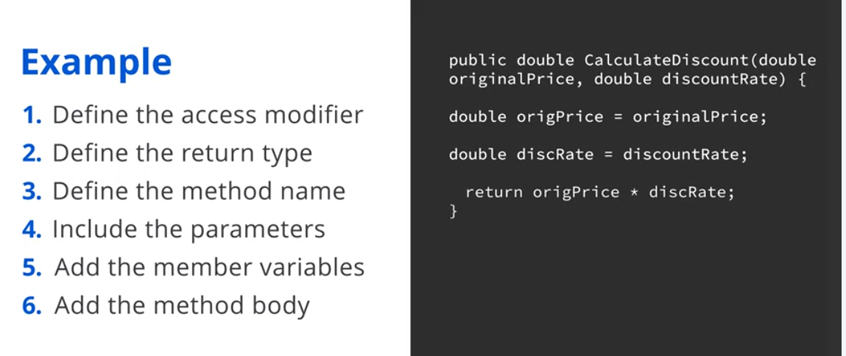

Common Use Cases
Methods provide a way to encapsulate and simplify repetitive tasks in C# programming. Some of the most common uses include:

Performing Calculations
Methods are often employed to execute repeated mathematical operations, such as adding or subtracting values or calculating averages. Placing the logic inside a method allows you to reuse the same operation across different parts of your code.

Example
public int Add(int a, int b)
{
return a + b;
}

Handling Events
Methods are crucial for building interactive applications. They can respond to user actions, such as mouse clicks or key presses, making your application responsive.

Example
private void Button_Click(object sender, EventArgs e)
{
Console.WriteLine("Button clicked");
}

Manipulating Data
Developers frequently use data-processing methods, like sorting arrays or modifying collections. Methods help ensure that these operations are executed consistently and efficiently.

Example
public List<int> SortList(List<int> numbers) {
numbers.Sort();
return numbers;
}
Activity – Methods in C#

Example 1: Defining a Method to Add Two Numbers

Problem Statement
Write a method that adds two numbers and returns the result. The method should take two integer parameters.

Step 1: Define the Method to Add Two Numbers
Code:
public int AddNumbers(int a, int b) { return a + b; }
Line-by-Line Explanation:
- public: Access Modifier - Indicates that the method is accessible from other classes. It defines the visibility of the method.
- int: Return Type - Specifies that the method returns an integer value. This is crucial for defining what type of value the method will output.
- AddNumbers: Method Name - The name of the method. It should be descriptive and indicate what the method does.
- (int a, int b): Parameters - These are the inputs to the method. a and b are placeholders for the values that will be passed to the method. Both are of type int.
- { return a + b; }: Method Body - Contains the logic of the method. return a + b; calculates the sum of a and b and returns the result to the caller.

Step 2: Implement and Test the Method
Code:
using System;
public class Program {
public static void Main() {

Console.WriteLine("Enter the first number:");
int num1 = Convert.ToInt32(Console.ReadLine());

Console.WriteLine("Enter the second number:");
int num2 = Convert.ToInt32(Console.ReadLine());

int result = AddNumbers(num1, num2);

Console.WriteLine("The sum of the numbers is: " + result);

}
static int AddNumbers(int a, int b) {
return a + b;
}
}
Line-by-Line Explanation:
- using System;: Namespace Import - Imports the System namespace, which is required for console input and output.
- class Program {: Class Definition - Defines a class named Program. In C#, methods must be contained within classes.
- static void Main() {: Main Method - The entry point of the program where execution starts. static means it can be called without creating an instance of the class, and void indicates it does not return a value.
- Console.WriteLine("Enter the first number:");: Prompt for Input - Displays a message asking the user to enter the first number.
- int num1 = Convert.ToInt32(Console.ReadLine());: Read and Convert Input - Reads the user’s input from the console, converts it to an integer, and assigns it to num1.
- Console.WriteLine("Enter the second number:");: Prompt for Input - Displays a message asking the user to enter the second number.
- int num2 = Convert.ToInt32(Console.ReadLine());: Read and Convert Input - Reads the second input, converts it to an integer, and assigns it to num2.
- int result = AddNumbers(num1, num2);: Call Method - Calls the AddNumbers method with num1 and num2 as arguments and stores the result in result.
- Console.WriteLine("The sum of the numbers is: " + result);: Display Result - Outputs the result of the addition to the console.
- static int AddNumbers(int a, int b) {: Method Definition - Defines the AddNumbers method that takes two integer parameters and returns their sum.
- return a + b;: Return Statement - Calculates the sum and returns it.

Step 3: Run the code
using System;
public class Program {
public static void Main() {
Console.WriteLine("Enter the original price:");
decimal originalPrice = Convert.ToDecimal(Console.ReadLine());

Console.WriteLine("Enter the discount rate (as a decimal, e.g., 0.20 for 20%):");
decimal discountRate = Convert.ToDecimal(Console.ReadLine());

decimal finalPrice = CalculateDiscount(originalPrice, discountRate);
Console.WriteLine("The final price after discount is: " + finalPrice);
}

static decimal CalculateDiscount(decimal originalPrice, decimal discountRate) {
return originalPrice * (1 - discountRate);
}
}

Example 2: Creating a Method to Calculate the Discount on a Product
Problem Statement
Write a method to calculate the discount on a product. The method should take two parameters: the original price and the discount rate, and return the final price after applying the discount.

Step 1: Define the Method to Calculate Discount
Code:
public decimal CalculateDiscount(decimal originalPrice, decimal discountRate) { return originalPrice * (1 - discountRate); }
Line-by-Line Explanation:
- public: Access Modifier - Makes the method accessible from other classes.
- decimal: Return Type - Specifies that the method returns a decimal value. This is suitable for financial calculations requiring precision.
- CalculateDiscount: Method Name - The name of the method, describing its function.
- (decimal originalPrice, decimal discountRate): Parameters - originalPrice and discountRate are the inputs to the method, both of type decimal.
- { return originalPrice * (1 - discountRate); }: Method Body - Calculates the final price after discount. 1 - discountRate gives the proportion of the price that remains after applying the discount.

Step 2: Implement and Test the Method
Code:
using System;
public class Program {
public static void Main() {
Console.WriteLine("Enter the original price:");
decimal originalPrice = Convert.ToDecimal(Console.ReadLine());

Console.WriteLine("Enter the discount rate (as a decimal, e.g., 0.20 for 20%):");
decimal discountRate = Convert.ToDecimal(Console.ReadLine());

decimal finalPrice = CalculateDiscount(originalPrice, discountRate);
Console.WriteLine("The final price after discount is: " + finalPrice);
}

static decimal CalculateDiscount(decimal originalPrice, decimal discountRate) {
return originalPrice * (1 - discountRate);
}
}
Line-by-Line Explanation:
- using System;: Namespace Import - Imports the required namespace for console operations.
- class Program {: Class Definition - Defines a class named Program.
- static void Main() {: Main Method - The entry point of the application.
- Console.WriteLine("Enter the original price:");: Prompt for Input - Asks the user to input the original price.
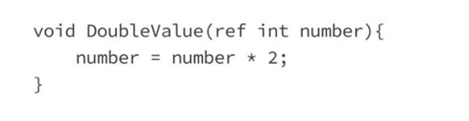
- decimal originalPrice = Convert.ToDecimal(Console.ReadLine());: Read and Convert Input - Reads the user input and converts it to a decimal.
- Console.WriteLine("Enter the discount rate (as a decimal, e.g., 0.20 for 20%):");: Prompt for Input - Asks the user to input the discount rate.
- decimal discountRate = Convert.ToDecimal(Console.ReadLine());: Read and Convert Input - Reads the discount rate and converts it to a decimal.
- decimal finalPrice = CalculateDiscount(originalPrice, discountRate);: Call Method - Calls the CalculateDiscount method with the user-provided values.
- Console.WriteLine("The final price after discount is: " + finalPrice);: Display Result - Outputs the final price after applying the discount.
- static decimal CalculateDiscount(decimal originalPrice, decimal discountRate) {: Method Definition - Defines the CalculateDiscount method.
- return originalPrice * (1 - discountRate);: Return Statement - Computes and returns the final price after discount.

Step 3: Run the code

using System;
public class Program {
public static void Main() {
Console.WriteLine("Enter the original price:");
decimal originalPrice = Convert.ToDecimal(Console.ReadLine());

Console.WriteLine("Enter the discount rate (as a decimal, e.g., 0.20 for 20%):");
decimal discountRate = Convert.ToDecimal(Console.ReadLine());

decimal finalPrice = CalculateDiscount(originalPrice, discountRate);
Console.WriteLine("The final price after discount is: " + finalPrice);
}

static decimal CalculateDiscount(decimal originalPrice, decimal discountRate) {
return originalPrice * (1 - discountRate);
}
}

Practical application of calling methods

Introduction
Calling methods in C# allows you to reuse code, making your programs more efficient and easier to manage. This summary covers defining, calling, and using methods in C#, along with handling return values and passing arguments.

Basics of Calling Methods
A method is a reusable block of code designed to perform a task. It consists of a header, which defines its name, return type, and parameters, and a body containing the actual code. To call a method, use its name followed by parentheses, passing arguments if necessary:
int result = AddNumbers(5, 10);
This example calls the AddNumbers method, passing 5 and 10 as arguments and storing the result in the result.

Method Return Values
Methods often return values, defined by the return type in the header. If a method returns nothing, it uses void. For example, the GetNumber method below returns the integer 42:
public int GetNumber()
{
return 42;
}
The return statement sends this value back to the calling code.

Passing Arguments to Methods
Methods can accept input data through arguments. These must match the parameters defined in the method. For example, in the CalculateSum method, two integers are passed as arguments:
int sum = CalculateSum(5, 10);
This method returns the sum of the two numbers.

Practical Examples of Calling Methods

Displaying a Welcome Message
public void DisplayWelcomeMessage()
{
MessageBox.Show("Welcome to GreenWay!");
}
This method is called without arguments and displays a welcome message.

Calculating a Sum
public int CalculateSum(int a, int b) {
return a + b;
}
The method adds two numbers and returns the result.

Validating User Age
public bool IsUserOldEnough(int age) {
return age >= 18;
}
This method checks if a user is old enough to access certain features, returning true or false.
Using Parameters in Methods
Introduction
Parameters in methods allow flexibility by enabling data (arguments) to be passed into the method. This allows methods to operate on different inputs, making the code more reusable and adaptable.
What Are Parameters?
Parameters are variables defined within a method’s signature that specify what input the method can accept. They act as placeholders for the values (called arguments) that will be passed into the method when it is called. This makes methods more flexible, allowing them to perform specific tasks based on different inputs without needing to rewrite the method.
Types of Parameters
Value Parameters
- Receive a copy of the argument.
- Changes to the parameter inside the method don’t affect the original argument.
Reference Parameters
- Receive a reference to the original argument.
- Changes made inside the method affect the original value.

How to Pass Data into Methods
The method signature defines parameters, and arguments matching the parameter types are passed when the method is called.
Example: Single Parameter
public void GreetUser(string userName)
{
MessageBox.Show("Hello, " + userName + "!");
}
GreetUser("Alice");
Output: "Hello, Alice!".
Example: Multiple Parameters
public void GreetUser(string userName, int lastLogin)
{
MessageBox.Show("Hello, " + userName + "! It's been " + lastLogin + " days since you last logged in.");
}
GreetUser("Alice", 2);
Output: "Hello, Alice! It's been 2 days since you last logged in".
Activity – Using parameters in methods
Example 1: Basic Method – Calculating the Area of a Rectangle
Problem Statement:
You are tasked with writing a method in C# that calculates the area of a rectangle. The method should accept two integer parameters: length and width. The method should return the calculated area, which is the product of the two parameters.
Step 1: Define the Method with Parameters
public static int CalculateArea(int length, int width) { // Code to calculate area }
Explanation:
- public: The method is accessible from outside its class.
- static: This indicates the method or variable belongs to the class itself, not to any instance of the class.
- int: This indicates that the method will return an integer value.
- CalculateArea: The name of the method, which describes its functionality.
- int length, int width: These are the method’s parameters. They allow you to pass values (length and width) to the method when you call it.
Step 2: Implement the Logic to Calculate the Area
public static int CalculateArea(int length, int width) { int area = length * width; return area; }
Explanation:
- int area = length * width;: This line of code multiplies the two parameters, length and width, and stores the result in a variable called area.
- return area;: This line returns the calculated area from the method back to the caller.
Step 3: Use the Method in the Main Program
using System;

public class Program
{
// The Main method: Entry point of the program
public static void Main()
{
// Prompt the user for the length of the rectangle
Console.WriteLine("Enter the length of the rectangle:");
int length = int.Parse(Console.ReadLine());
// Prompt the user for the width of the rectangle
Console.WriteLine("Enter the width of the rectangle:");
int width = int.Parse(Console.ReadLine());
// Call the function to calculate the area and store the result in 'area'
int area = CalculateArea(length, width);
// Output the result
Console.WriteLine("The area of the rectangle is: " + area);
}
// Define the method to calculate the rectangle's area
public static int CalculateArea(int length, int width)
{
int area = length * width;
return area;
}
}

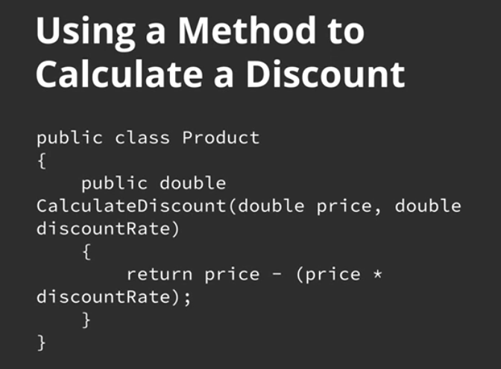
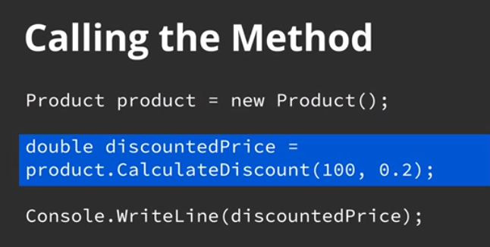
Example 2: Advanced Method – Calculating the Perimeter of a Rectangle
Problem Statement:
Write a method in C# that calculates the perimeter of a rectangle. The method should accept two integer parameters: length and width. The method should return the perimeter, calculated using the formula:
Perimeter = 2 * (length + width).
Step 1: Define the Method with Parameters
public static int CalculatePerimeter(int length, int width) { // Code to calculate perimeter }
Explanation:
- public: The method is accessible from other classes.
- static: This indicates the method or variable belongs to the class itself, not to any instance of the class.
- int: The return type of the method, indicating that it will return an integer value.
- CalculatePerimeter: The name of the method.
- int length, int width: These parameters allow the method to accept the length and width values when it is called.
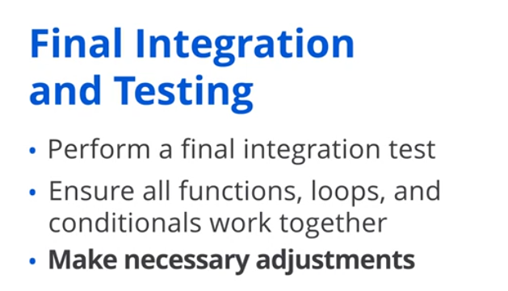
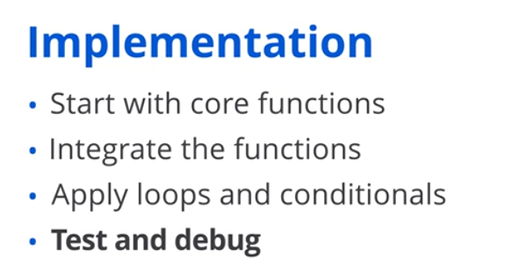
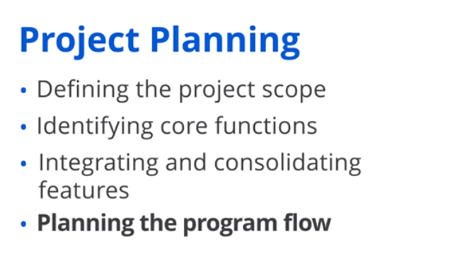
Step 2: Implement the Logic to Calculate the Perimeter
public static int CalculatePerimeter(int length, int width) { int perimeter = 2 * (length + width); return perimeter; }
Explanation:
- int perimeter = 2 * (length + width);: This line calculates the perimeter of the rectangle by summing the length and width and then multiplying the result by 2.
- return perimeter;: This returns the calculated perimeter to the calling method.
Step 3: Use the Method in the Main Program
using System;
public class Program
{
public static void Main()
{
Console.WriteLine("Enter the length of the rectangle:");
int length = int.Parse(Console.ReadLine());
Console.WriteLine("Enter the width of the rectangle:");
int width = int.Parse(Console.ReadLine());
int perimeter = CalculatePerimeter(length, width);
Console.WriteLine("The perimeter of the rectangle is: " + perimeter);
}
public static int CalculatePerimeter(int length, int width)
{
return 2 * (length + width);
}
}
Explanation:
- Console.WriteLine("Enter the length of the rectangle:");: This line requests input from the user
- int length = int.Parse(Console.ReadLine());: This line reads the user’s input for the length of the rectangle and converts it into an integer.
- int perimeter = CalculatePerimeter(length, width);: This line calls the CalculatePerimeter method, passing the user inputs length and width as arguments.
- Console.WriteLine("The perimeter of the rectangle is: " + perimeter);: This prints the perimeter to the console.

Developing Programs With Functions and Methods

Introduction
Developing programs using functions and methods allows for efficient problem-solving and code management. These reusable blocks of code make it easier to break down complex tasks, leading to more organized, maintainable, and scalable solutions.

Functions: Simplifying Repetitive Tasks
Functions are self-contained blocks of code that perform specific tasks, making them ideal for solving repetitive problems. By using functions, developers can avoid rewriting code for frequent tasks.

Example
A JavaScript function like calculateTotalPrice can iterate through a list of product prices, summing them to return the total. This eliminates the need to repeat code for each calculation manually.

Benefit
Functions improve code readability and reusability and reduce the likelihood of errors, particularly in complex applications.

Methods: Structured Operations in OOP
Methods are similar to functions but are used in object-oriented programming (OOP). They operate within the context of a class, allowing for actions on an object’s data.

Example
A Product class in C# might contain a method CalculateDiscount that calculates a price reduction based on a given discount rate. This modular design allows the method to be reused across multiple instances of the product object.

Benefits
Methods make maintaining and extending OOP-based programs easier, promoting clean code and better organization.

Modularity: Enhancing Code Structure
Modularity breaks a program into smaller, self-contained units such as functions and methods. This approach offers several advantages:
- Improved readability: Code is easier to understand because each function or method is responsible for a single task.
- Reusability: Modular functions and methods can be reused across different program parts or projects.
- Easier testing: Isolating tasks in individual functions or methods makes testing and debugging simpler and more efficient.

Comprehensive Program Development
A comprehensive program integrates all concepts—functions, methods, loops, and conditionals—to solve real-world problems. The process typically includes:
- Project planning: Define the scope, objectives, and necessary functions.

- Implementation: Code and test core functions individually before integrating them into the program flow.

- Final testing: Ensure all components (functions, methods, loops) work together seamlessly.

